Chapter 4

The input of our project will be the photo the comes from the camera that is in the traffic gate, our first model will do some image preprocessing in the image like binary converting or resizing the image, then aggregation in addition to segmentation to get the car plate form the hole car image more over get the car plate content to know the owner of the car and then adding fine to him.

Output of our system will be report to the user contain the details of the user.

Context free Diagram

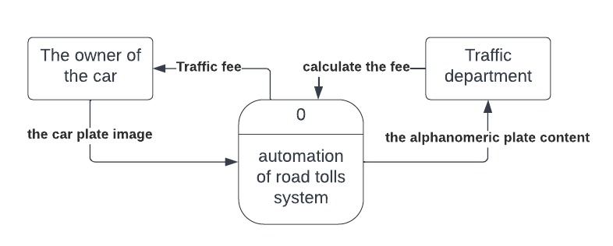

Data Flow Diagram

Figure, represents a scenario for data flow between model and application. In this scenario the model takes input image to do its operations for the license plate recognition through detecting the car plate, character recognition. In the application scenario the user signs up if it’s first time, sign in to access his data, pay the car traffic fine, notify if the car is stolen

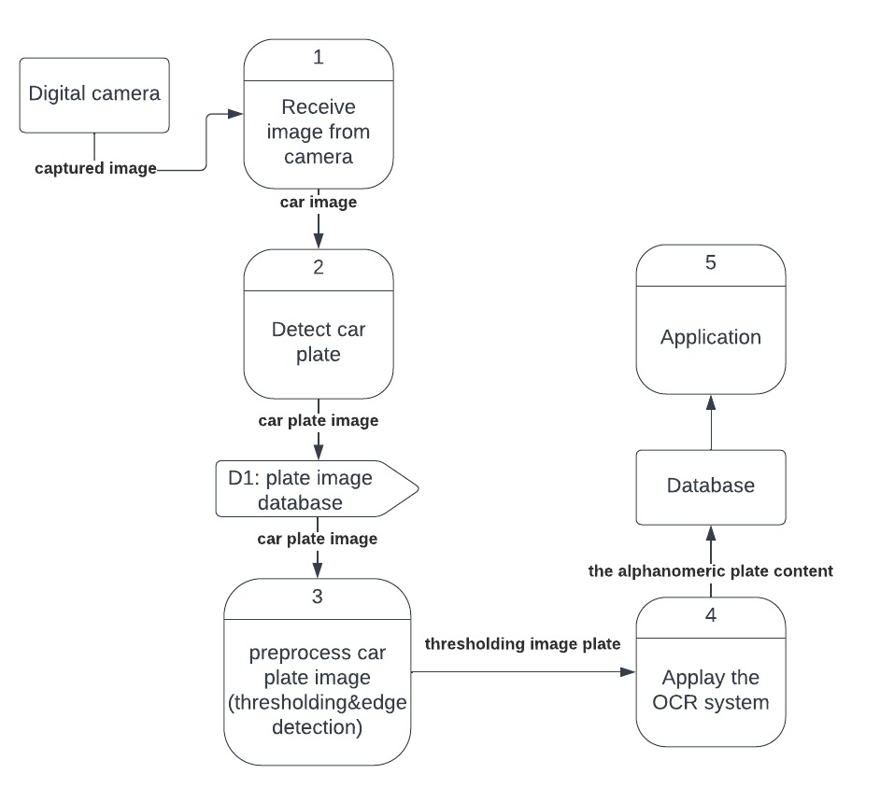

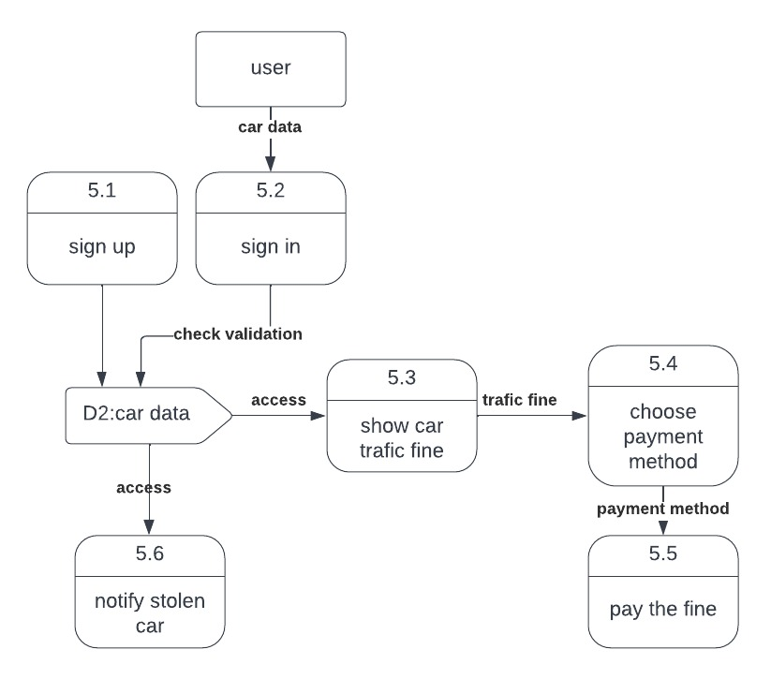

Use Case Diagram

Use Case Diagram :-

* Use cases represent system functionality from the user`s perspective.
* Use case diagrams describe who will use the system and in what ways the user expects to interact with the system.
* Use case diagrams represent the interactions between use cases and actors.
* Use case diagram represents the interactions between system, external systems, and users.

Use case scenario:-

* a use case scenario represents the sequence of events along with other information that relates to this use case.
* A typical use case specification template includes the following information:-

-Primary Actor

-Secondary Actor (if exist)

-Include use case (if exist)

-Purpose

-Pre and post condition

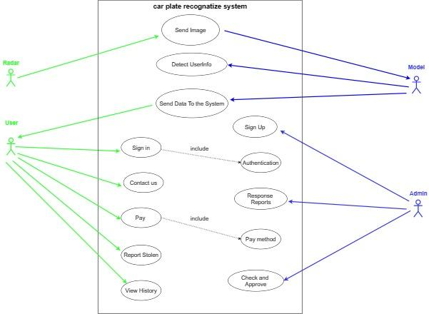

| Send Image | Use case Name |
| --- | --- |
| Radar Camera | Primary Actor |
| Model | Secondary Actor |
| Radar send token image to the model. | Purpose |
| Radar took an image | Pre-conditions |
| The model Receives the image and processes it. | Post-conditions |

| Detect User Information | Use case Name |
| --- | --- |
| Model | Primary Actor |
| The model process the image and illustrate the required details of the image. | Purpose |
| The model has an image to process it. | Pre-conditions |
| the image details save in the server of the model. | Post-conditions |

| Send data to the system | Use case Name |
| --- | --- |
| Model | Primary Actor |
| user | Secondary Actor |
| The model sends the car details to the user account in the system.. | Purpose |
| The model must have the image details that have been processed. | Pre-conditions |
| The image details saved in user account in the system. | Post-conditions |

| Sign Up | Use case Name |
| --- | --- |
| Admin | Primary Actor |
| Admin add user access information to the system. | Purpose |
| Admin have the user information. | Pre-conditions |
| User's information will be added to the system. | Post-conditions |

| Sign in | Use case Name |
| --- | --- |
| User | Primary Actor |
| User enter to the system using his sign in information. | Purpose |
| Authentication: To authenticate if a user's information is in the system or not. | Include use case |
| User has the right information to get into the system. | Pre-conditions |
| Get Access to the system successfully. | Post-conditions |

| Contact Us | Use case Name |
| --- | --- |
| User | Primary Actor |
| User can send report about.his problem. | Purpose |
| User must be logged to the system. | Pre-conditions |
| The report will be sent to the system.. | Post-conditions |

| Response Reports | Use case Name |
| --- | --- |
| Admin | Primary Actor |
| Admin can response to the reports of the users.. | Purpose |
| There are some reports to deal with it. | Pre-conditions |
| Send feedback to the user's reports. | Post-conditions |

| Pay | Use case Name |
| --- | --- |
| User | Primary Actor |
| User can pay his fines using pay function. | Purpose |
| Pay method: user choose how he will pay for the fine | Include Use case |
| There is a fine in the user's account. | Pre-conditions |
| The fine is canceled after the payment. | Post-conditions |

| Report Stolen | Use case Name |
| --- | --- |
| User | Primary Actor |
| User can report the system about his stolen car. | Purpose |
| His car was stolen. | Pre-conditions |
| If the report approved by the system it will send a warning to the road patrols | Post-conditions |

| Check and Approve | Use case Name |
| --- | --- |
| Admin | Primary Actor |
| Admin check if the user's report for stolen car true or by mistake, if true then approve the report.. | Purpose |
| There is a report about stolen car and check if the report right or wrong. | Pre-conditions |
| If the report was right the admin will approve the stolen report. | Post-conditions |

| View History | Use case Name |
| --- | --- |
| User | Primary Actor |
| User can view his historical fines. | Purpose |
| User must be logged into the system. | Pre-conditions |
| Details of the fines will e viewed to the user. | Post-conditions |

sequence Diagram

A sequence diagram is a type of interaction diagram because it describes how -and

in what order- a group of objects works together. These diagrams are used by

software developers and business professionals to understand requirements for a

new system or to document an existing process

In the following section we display Sequence Diagram of system

